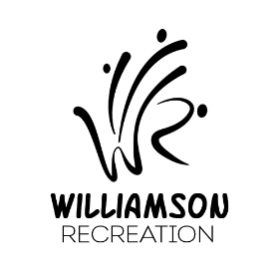
Williamson Apple Blossom Main Street Mile
Registration Form

TIP!
For faster registration, bring completed form with you the morning of the race!

REGISTRATION: On-line at www.williamsonrec.org
Main Street from 11:30am – 12:15pm on race day
WHO: Children in grades K – 6
WHAT: One mile run…fun for all!
WHEN: Sunday of Apple Blossom Weekend: Race starts at 12:30pm
WHERE: Start / Finish on Main Street
COST: $2 per child
WINNERS: Announced at 1:15 pm at Bandstand
All runners will receive a finisher ribbon, and a trophy will be awarded to 1st place overall boy and girl.
**PLEASE NOTE: Participants, family, and friends of participants, when race is done, please refrain from crowding around the Placement Board. You are ALL asked to wait until the announcement is made that times are ready for viewing. NO EXCEPTIONS.
QUESTIONS?? Contact Melisa Blankenberg at mblanks827@gmail.com
******************************************************************************************
WAIVER: I understand that running a road race is a potentially hazardous activity, and I assume all risks associated with my child running or walking this event. I have read the entry information and release the Williamson Recreation Committee, Inc. and all others connected with this event from any claims or liabilities of any kind arising from my child’s participation in this event.

____________________________________________________ ____________
Parent / Guardian Signature (required) Date Signed
Please Print LEDGIBLY!
Name of Child(ren) | Boy or Girl  (Circle) | Age | Grade
 | B G
 | B G
 | B G
 | B G
 | B G

